## **[Top Custom Web Development Companies in Malaysia**

## **Top Custom Web Development Solutions**



IHELP delivers innovative web applications for global leaders and startups. With a proven track record in enterprise development, we are committed to excellence and high-quality outcomes.

* Industry Expertise:
* Cutting-Edge Technology
* Client-Centric Approach:

## **How IHELP Can Help You to Grow Your Business**

* **Responsive Design  
  Ensure the website is mobile-friendly and adapts seamlessly to various screen sizes.**
* **User-Friendly Navigation  
  Implement intuitive navigation to enhance user experience and accessibility.**
* **SEO Optimization  
  Integrate SEO best practices to improve visibility on search engines and attract organic traffic.**
* **Content Management System (CMS)  
  Provide a robust CMS for easy content updates and management without technical expertise.**
* **E-commerce Functionality  
  Include secure payment gateways, shopping carts, and inventory management for online stores.**
* **Analytics and Reporting Tools  
  Incorporate tools for tracking user behavior and website performance for data-driven decision-making.**
* **Fast Loading Speed  
  Optimize website performance to ensure quick loading times, enhancing user satisfaction.**
* **Security Features  
  Implement SSL certificates, data encryption, and regular security updates to protect user data.**
* **Customizable Templates  
  Offer customizable design templates to reflect the brand's identity and meet specific business needs.**
* **Integration with Third-Party Services  
  Facilitate integration with various APIs and services, such as CRM, email marketing, and social media platforms.**
* 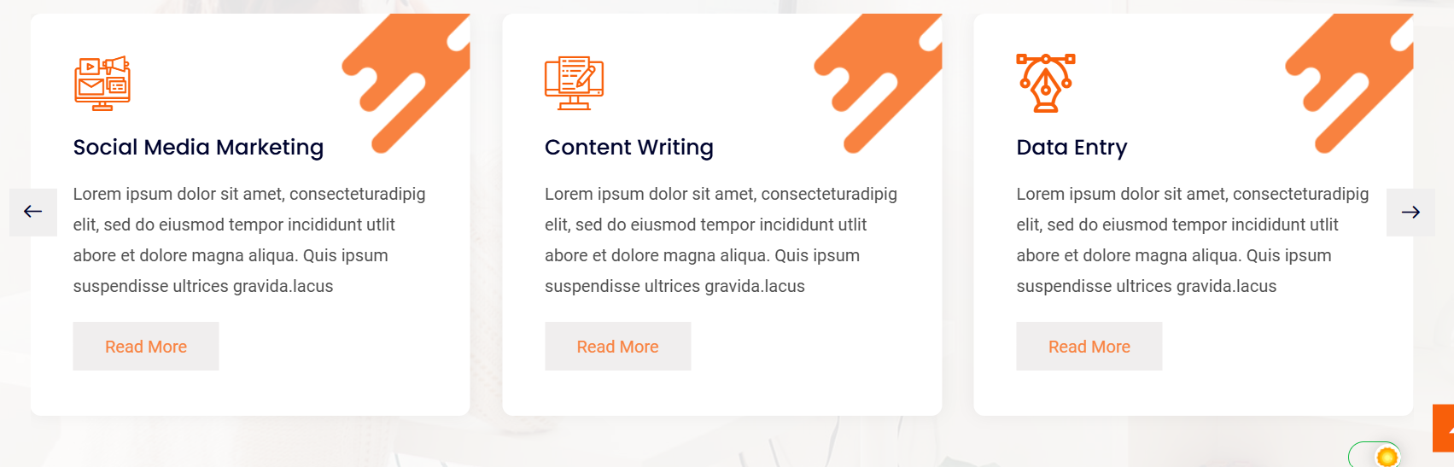

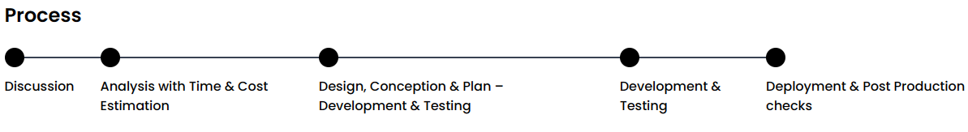

<https://templates.hibootstrap.com/vconn/default/index-2.html>

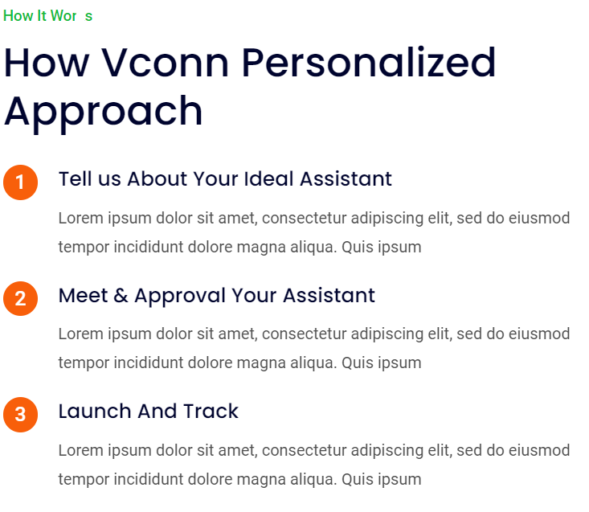

## **OUR WEBSITE SOLUTIONS**

* Corporate Website
* Portfolio Website
* Membership Website
* E-commerce
* Member Database
* Reward Points
* Payment Gateway
* Web Design & development
* Web application Design & development



**Reference** 

**We will add later**

